PRESS RELEASE

43rd ASEAN 2023 Communications and Media Team

No.55/SP/TKM-ASEAN2023/ENG/9/2023

ASEAN Meeting on Political and Security Pillar: APSC Blueprint 2016-2025 Implementation 99 Percent Completed

Jakarta, 4 September 2023 – “ASEAN must be prepared to address various challenges, both internal and external. The implementation of ASEAN’s Political and Security Pillar is overshadowed by the Myanmar issue, geopolitical tensions and rivalries are accelerating, which may lead to open conflict if not addressed.” This was conveyed by the Indonesian Coordinating Minister for Political, Legal, and Security Issues Mahfud MD in his remarks while chairing the 27th ASEAN Political and Security Community (APSC) Meeting with the Minister for Foreign Affairs in Jakarta (4/9/2023).

“We should not let the same situation happen to our region and undermine the progress that ASEAN has worked for since 1967,” he stated.

APSC must also be able to respond to challenges in the region especially trafficking in persons (TIP) based on online scams and other transnational crimes. Coordinating Minister Mahfud invited ASEAN countries to strengthen regional cooperation, including border management, cross-border legal assistance, and exchange of information. The Coordinating Minister also urged the implementation of the Human Trafficking Declaration adopted at the 42nd ASEAN Summit in Labuan Bajo last May by various ASEAN sectoral bodies.

Minister for Foreign Affairs Retno Marsudi further elaborated and conveyed three main aspects that APSC need to focus on:

First, addressing non-traditional security challenges.

In the past three years, the Indonesian government has handled more than 2,700 cases of human trafficking which involve online scams. Interpol report stated that the total net cost of cybercrime increases by 15% annually until 2025.

"This is the reason why Indonesia is pursuing the ASEAN Leaders' Declaration on ASEAN Human Rights Dialogue," said Foreign Minister Retno. Indonesia will also host the 5th ASEAN Human Rights Dialogue this year.

Second, fostering regional human rights progress

ASEAN must keep up with the ever-evolving human rights challenges to better promote and protect human rights, including through engaging in inclusive dialogue.

“This is the reason why Indonesia pursues the Leaders’ Declaration on ASEAN Human Rights Dialogue,” said Minister Retno. Indonesia will also host the 5th Human Rights Dialogue this year.

Third, enhanced maritime cooperation

The Indo-Pacific region holds strategic potential. However, the interests of major global powers could jeopardize our regional peace and stability.

Moving forward, ASEAN must be more consistent in applying international law and regional agreements at the heart of efforts to establish a regional architecture. This mechanism will hopefully be able to change the paradigm of rivalry into one of cooperation.

During the meeting, the ASEAN member-states expressed their appreciation for the implementation of the APSC 2016-2025 Blueprint which is 99 percent completed. They also underlined the importance of signing the Southeast Asian Nuclear-Weapon Free Zone (SEANWFZ) by nuclear states, combating TIP and other transnational crimes, as well as respect for human rights.

***

For further information, please contact the following:

Director for Information and Media at the Indonesian Ministry of Foreign Affairs – Hartyo Harkomoyo (0811831899)

Get more information at http://asean2023.id, https://infopublik.id/kategori/asean-2023, and https://indonesia.go.id/kategori/ragam-asean-2023

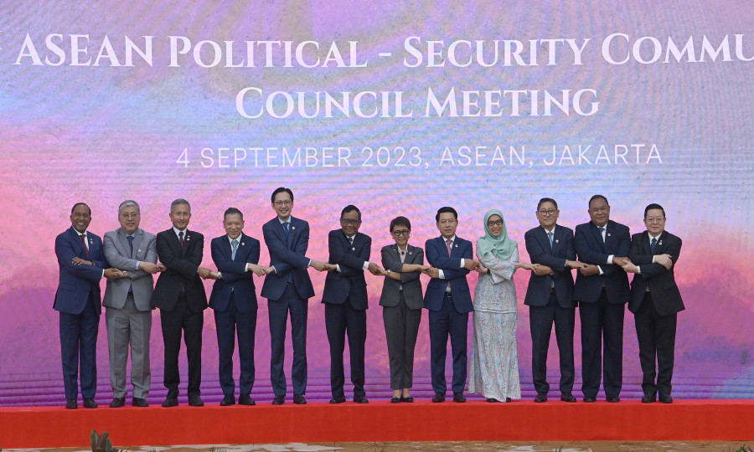

Coordinating Minister for Political, Legal, and Security Issues Mahfud MD chairs the 27th ASEAN Political and Security Community (APSC) Meeting with the Minister for Foreign Affairs in Jakarta (4/9) (Foto: Kemlu RI/Aditya Pradana Putra)

